EXHIBIT A
PARCEL A SOIL TRANSFER — EVIDENTIARY FINDINGS AND REGULATORY VIOLATIONS

Date: | August 22, 2026
Re: | DOE Leasing Parcel A — Paducah Gaseous Diffusion Plant (PGDP), McCracken County, Kentucky
Prepared In Connection With: | Environmental Compliance Audit / Regulatory Review

Prefatory Statement
This Exhibit presents documentary, quantitative, and correspondence-based evidence establishing that large-scale soil transfer operations conducted at Department of Energy (DOE) Leasing Parcel A resulted in the off-site transport of CERCLA-affected material in excess of officially reported volumes, to an agricultural destination (Warford Farm) inconsistent with the land-use restrictions governing Parcel A, and without adequate characterization of radiological and chemical contaminants. The evidence is organized into five categories: (1) volumetric analysis, (2) chain-of-custody deficit, (3) regulatory restrictions, (4) quantitative risk exceedances, and (5) invalid chromium speciation assumptions.

1. Volumetric Evidence — GeM Cut/Fill Analysis (Exhibit 1, July 22, 2026)

Source: GeM DWM Response Letter, Exhibit 1 — Cut/Fill Analysis (Current Survey vs. Paducah Original Topo), dated July 22, 2026.
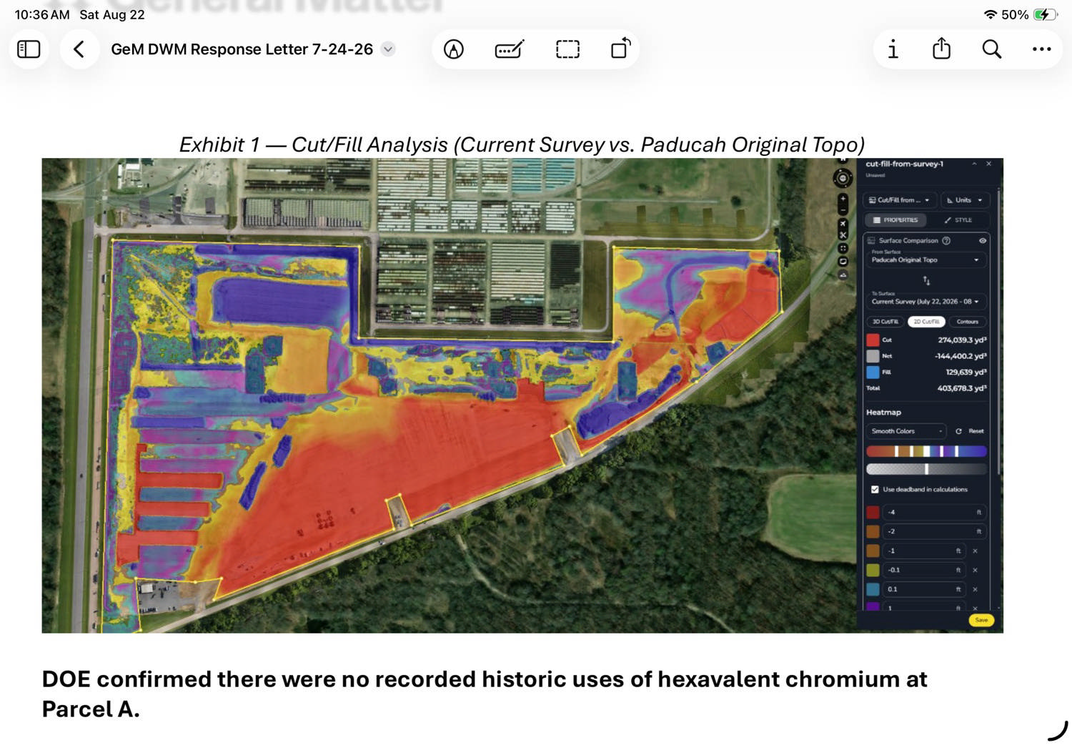
Exhibit 1 — Cut/Fill Analysis: Current Survey (July 22, 2026) vs. Paducah Original Topo. Red/orange areas indicate net fill (elevation gain); blue/purple areas indicate net cut (elevation loss).
The GeM Cut/Fill Analysis compares current ground surface conditions at Leasing Parcel A against the original topographic baseline. The analysis yields the following surveyed volumes:

Metric | Volume (Cubic Yards)
Total Cut (material removed) | 274,039.3
Total Fill (material redistributed on-site) | 129,639.0
Net Removal (off-site export required) | −144,400.2
Total Disturbed Volume | 403,678.3

Interpretation: The 274,039 CY of cut represents total excavation from Parcel A. The 129,639 CY of fill represents material redistributed back onto Parcel A as part of on-site regrading operations. The net figure of −144,400 CY represents the volume of soil that permanently departed Parcel A and required off-site disposal or placement.

2. Chain-of-Custody Deficit — Unaccounted Soil Volume

Source: GeM Cut/Fill Analysis (surveyed net) vs. SWPPP and official transport records.
Official records, including the Dumey Contracting Stormwater Pollution Prevention Plan (SWPPP) dated July 15, 2026, document the transport of 115,000 cubic yards of soil to the Warford Farm off-site location. The GeM survey documents a net removal of 144,400 cubic yards from Parcel A. This produces the following deficit:

Item | Volume (Cubic Yards) | Source
Net off-site export (surveyed) | 144,400 | GeM Cut/Fill Analysis, 7/22/2026
Documented transport to Warford Farm | 115,000 | SWPPP / Official Records
Unaccounted deficit | ~29,400 | Calculated difference

Finding: Approximately 29,400 cubic yards of soil removed from a CERCLA-controlled, DOE-restricted parcel has no documented destination or chain of custody. This volume — equivalent to approximately 11–12 Olympic swimming pools — exceeds a rounding tolerance and constitutes a material discrepancy requiring accounting. The absence of documentation for this volume may represent: (a) placement at a second, undisclosed off-site location; (b) burial or concealment within Parcel A boundaries not reflected in the survey; or (c) haul loads not captured in existing SWPPP documentation.

3. Regulatory Restrictions — DOE Lease Conclusions (DOE 2024 Report, Page 20 of 129)

Source: U.S. Department of Energy, Leasing Parcel A Data Package, 2024. Conclusions Section, Page 20 of 129.
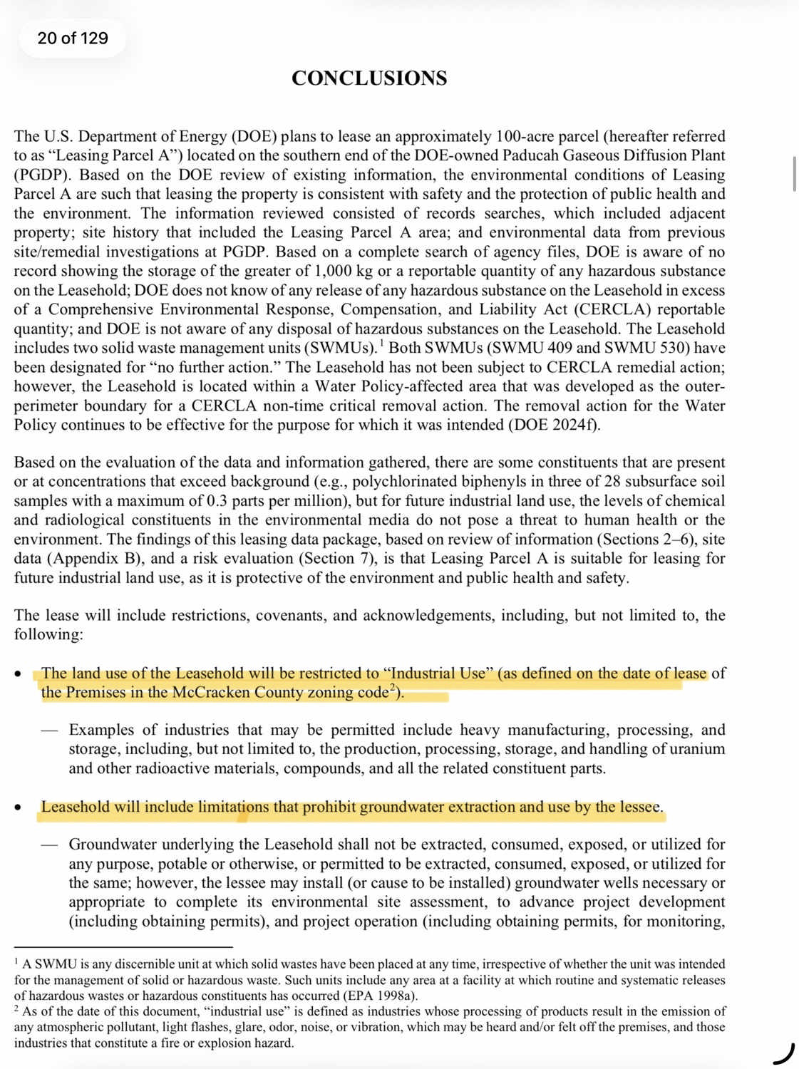
DOE 2024 Report, Page 20 — CONCLUSIONS: Land use restricted to Industrial Use (highlighted); groundwater extraction prohibited (highlighted).
The DOE Conclusions page establishes binding lease restrictions applicable to all activities conducted on or in connection with Parcel A. The following restrictions are directly relevant to the soil transfer operations documented herein:
Restriction 1 — Industrial Use Only:

"The land use of the Leasehold will be restricted to 'Industrial Use' (as defined on the date of lease of the Premises in the McCracken County zoning code)."

Examples of permitted industrial activities include heavy manufacturing, processing, and storage, including the production, processing, storage, and handling of uranium and other radioactive materials.
Restriction 2 — Groundwater Extraction Prohibited:

"Leasehold will include limitations that prohibit groundwater extraction and use by the lessee."

Groundwater underlying the Leasehold shall not be extracted, consumed, exposed, or utilized for any purpose, potable or otherwise.
Regulatory Significance: Warford Farm, by nature an agricultural property, constitutes a receptor environment fundamentally inconsistent with the Industrial Use restriction under which Parcel A soil was characterized and risk-evaluated. The placement of Parcel A-origin soil at an agricultural site exposes receptors — including potential residents, farm workers, and livestock — to exposure pathways (ingestion, dermal contact, dust inhalation) that are substantially more severe than those modeled under Industrial Use assumptions. This constitutes a violation of CERCLA institutional controls governing Parcel A.

4. Quantitative Risk Data — DOE 2025 Risk Evaluation Tables

Source: DOE 2025 Leasing Parcel A Data Package, Risk Evaluation Section (GeM Response Letter Tables 2, 3, 6, 7, 8).

Sub-section 4A — Surface Soil Risk (Resident Receptor)
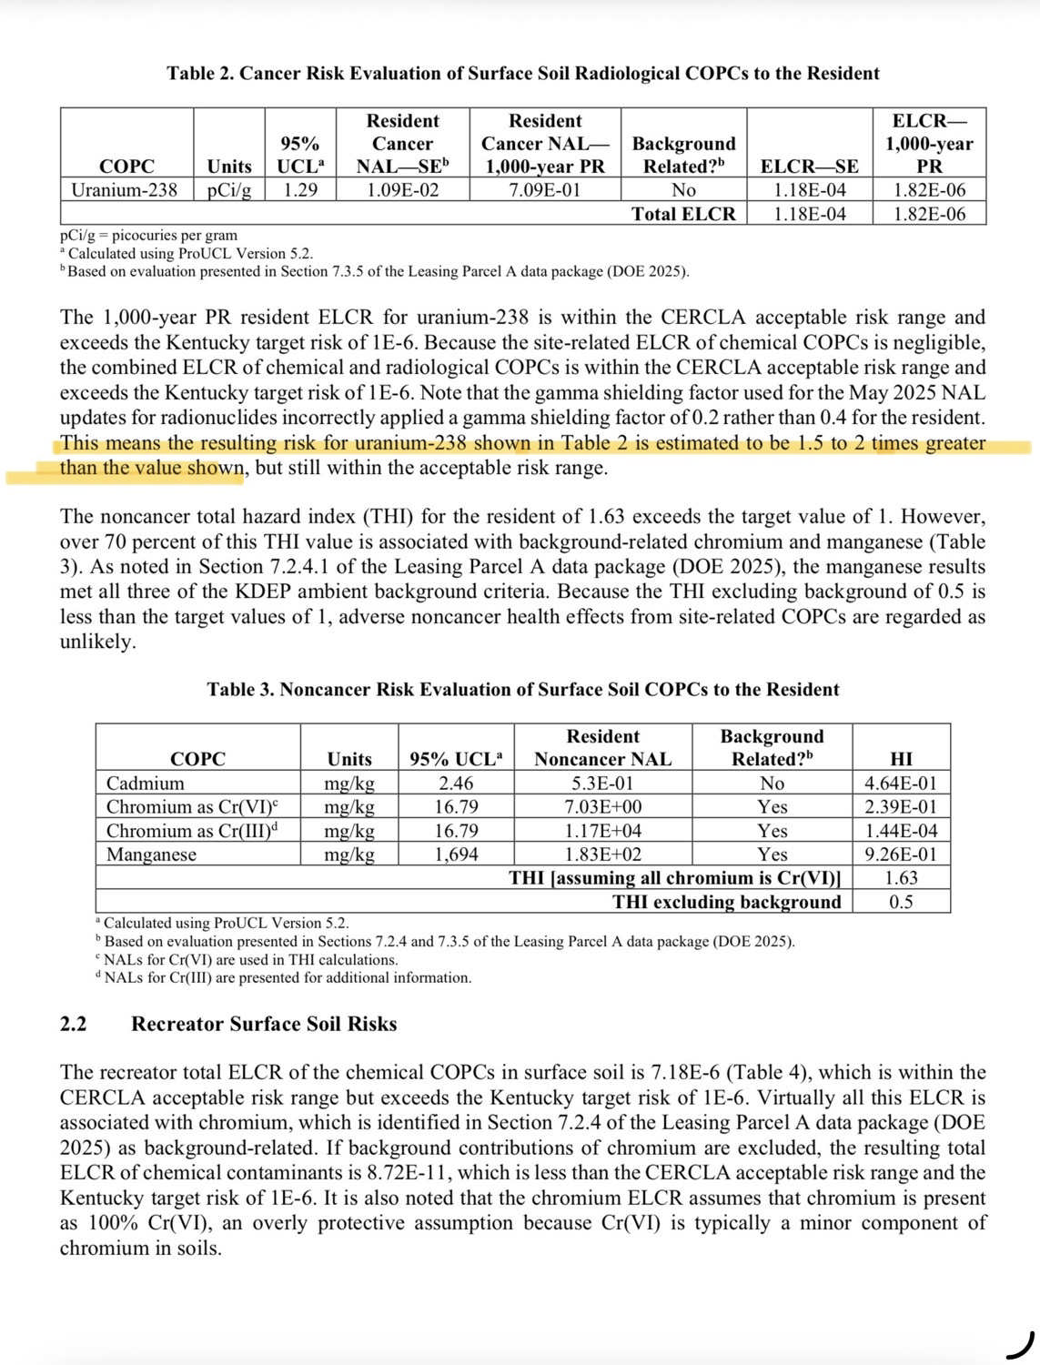
Tables 2 & 3 — Surface Soil Cancer and Noncancer Risk Evaluation. Highlighted text confirms gamma-shielding calculation error resulting in 1.5–2× underestimate of uranium-238 risk.

Parameter | Value | Threshold | Status
Uranium-238 ELCR (Surface Soil, Resident) | 1.18E-04 | 1E-06 (Kentucky target) | EXCEEDS
THI — all chromium as Cr(VI) | 1.63 | 1.0 (safe limit) | EXCEEDS
THI — excluding background | 0.5 | 1.0 | Within range
Gamma-shielding factor applied | 0.2 | 0.4 (correct value) | ERROR
Corrected uranium-238 risk estimate | 1.5–2× reported value | — | UNDERESTIMATED

Gamma-Shielding Error (quoted directly from source document):

"Note that the gamma shielding factor used for the May 2025 NAL updates for radionuclides incorrectly applied a gamma shielding factor of 0.2 rather than 0.4 for the resident. This means the resulting risk for uranium-238 shown in Table 2 is estimated to be 1.5 to 2 times greater than the value shown."

Sub-section 4B — Subsurface Soil Risk (Resident Receptor)
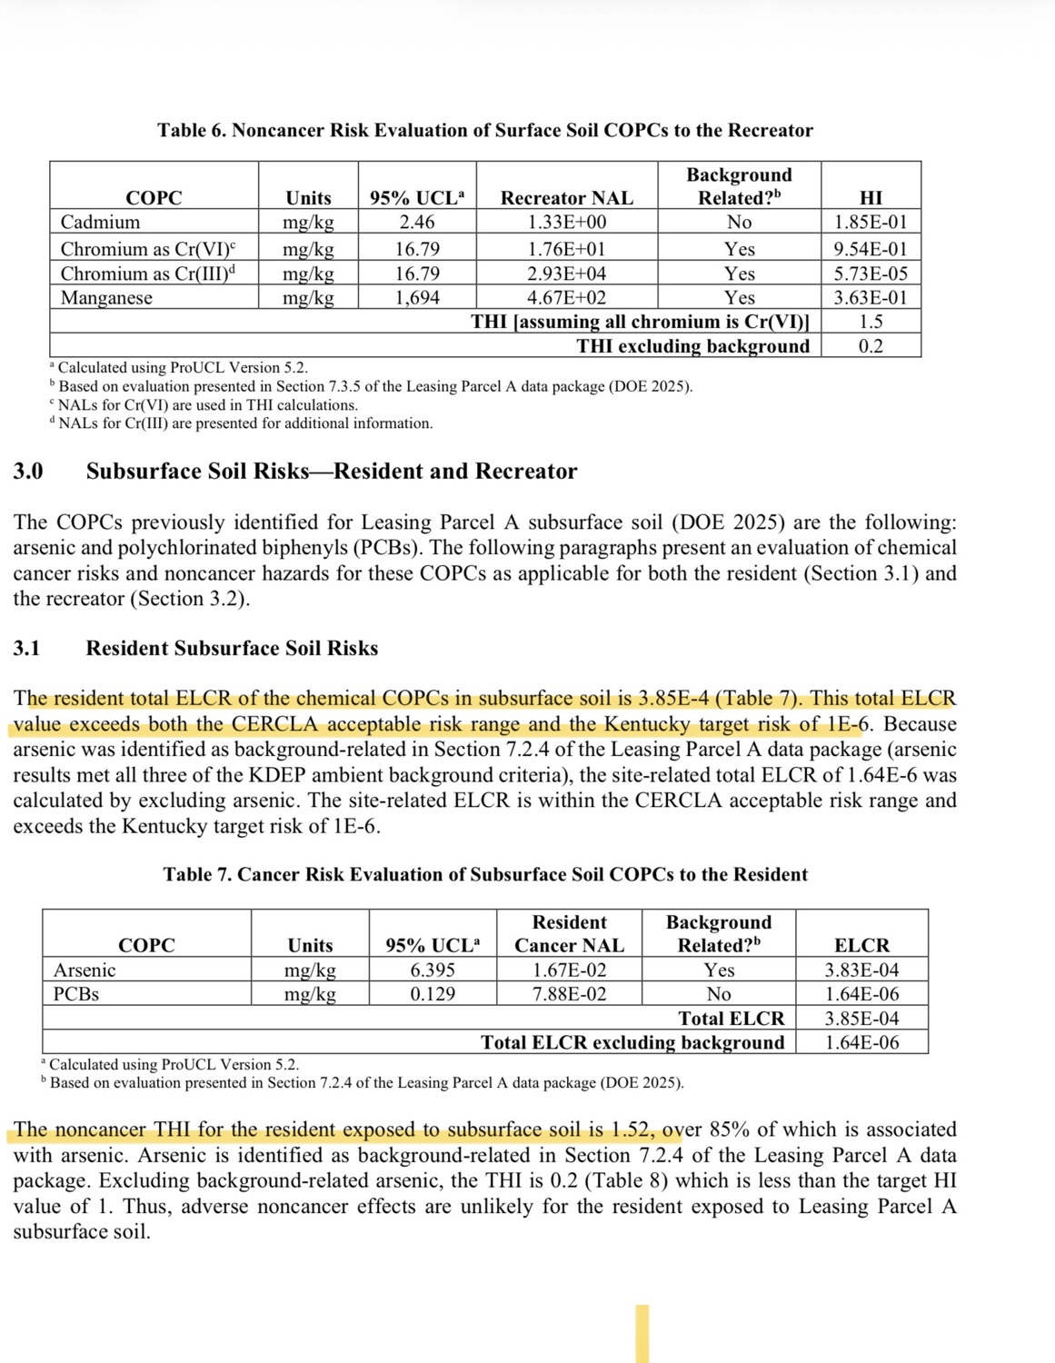
Tables 6 & 7 — Subsurface Soil Cancer and Noncancer Risk Evaluation. ELCR of 3.85E-4 and THI of 1.52 both exceed CERCLA and Kentucky regulatory thresholds.

Parameter | Value | Threshold | Status
Total ELCR — Subsurface Soil (Resident) | 3.85E-04 | 1E-04 (CERCLA upper bound) | EXCEEDS
Total ELCR — Subsurface Soil (Resident) | 3.85E-04 | 1E-06 (Kentucky target) | EXCEEDS
THI — Subsurface Soil (Resident) | 1.52 | 1.0 (safe limit) | EXCEEDS
THI excluding background | 0.2 | 1.0 | Within range

Audit Finding: The risk data confirms that subsurface soil at Parcel A carried cancer risk (ELCR) and noncancer hazard (THI) values exceeding both federal CERCLA and Kentucky regulatory thresholds at the time of excavation. The transport of this material to Warford Farm — without receptor-specific risk evaluation for agricultural land use — represents a material failure of the risk management framework applied to this project.

5. Invalid Chromium Speciation Assumption — Kelly Layne (ETAS), July 24, 2026

Source: Email from Kelly Layne, Paducah Project Manager, Enterprise Technical Assistance Services, Inc. (ETAS), Contractor to the U.S. Department of Energy. Dated: Friday, July 24, 2026, 9:30:54 AM. Subject: [External] - RE: Chromium(VI) Use At Parcel A.
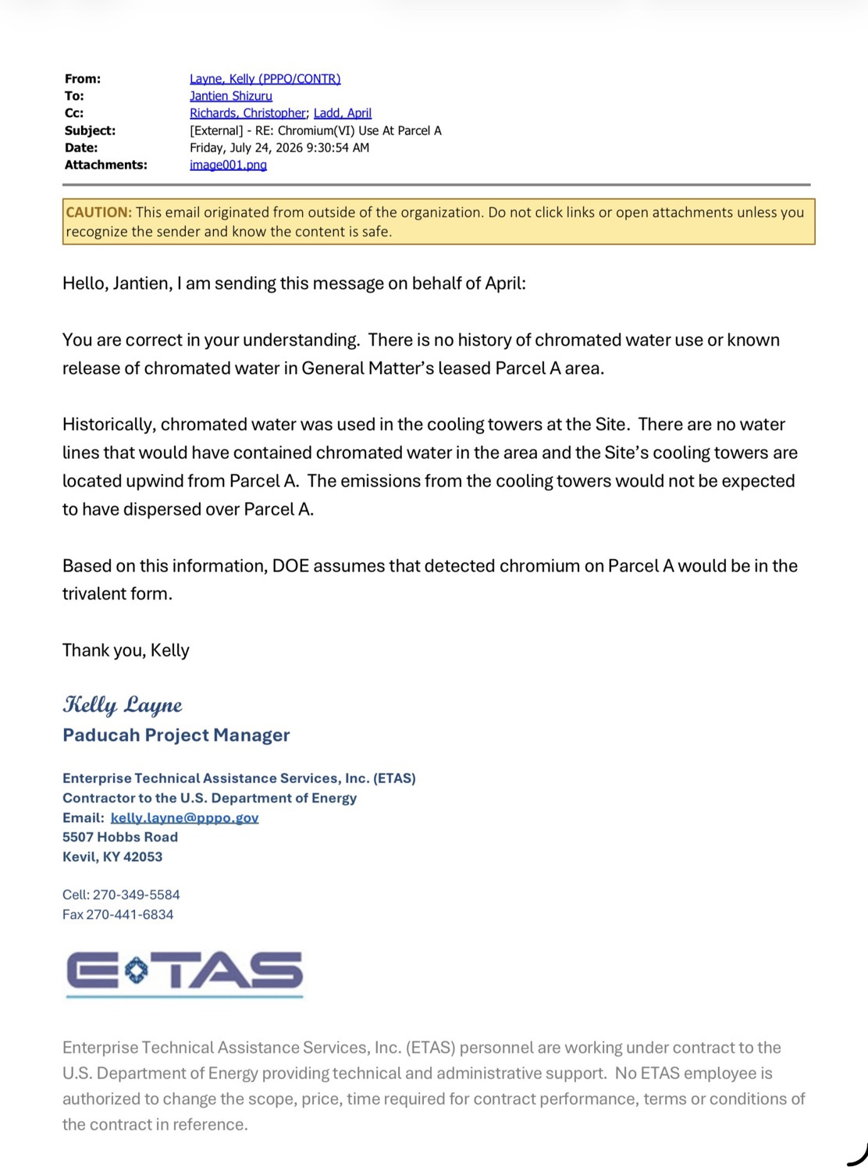
Email — Kelly Layne, ETAS/DOE PPPO, July 24, 2026: DOE assumes detected chromium is trivalent Cr(III) based solely on wind-direction narrative. No laboratory speciation testing was conducted.
Quoted Language from Email:

"There is no history of chromated water use or known release of chromated water in General Matter's leased Parcel A area."

"The emissions from the cooling towers would not be expected to have dispersed over Parcel A."

"Based on this information, DOE assumes that detected chromium on Parcel A would be in the trivalent form."

Audit Finding — Invalid Assumption
DOE's determination that all chromium detected at Parcel A is trivalent Cr(III) — the less toxic form — rests exclusively on a wind-direction narrative. No laboratory speciation analysis was performed to empirically distinguish Cr(III) from hexavalent Cr(VI). This assumption is scientifically invalid for the following reasons:
- Wind patterns are not static or unidirectional. Historical deposition under varying atmospheric conditions cannot be excluded by reference to prevailing wind direction alone.
- The risk tables (Tables 3 and 6) calculate THI using Cr(VI) NALs as the conservative assumption — yet the underlying speciation determination supporting this model was made without empirical testing.
- If any portion of detected chromium is Cr(VI), the risk calculations are further understated beyond the already-documented gamma-shielding error.
- The soil transported to Warford Farm carries this unresolved speciation uncertainty into an agricultural receptor environment where Cr(VI) exposure pathways are more severe and direct.

6. Summary of Audit Findings

Finding No. | Subject | Key Evidence | Regulatory Implication
1 | Net off-site removal: 144,400 CY | GeM Cut/Fill Analysis, 7/22/2026 | Establishes true transport volume
2 | Documented transport to Warford Farm: 115,000 CY | SWPPP / Official Records | Confirms off-site agricultural placement
3 | Unaccounted soil deficit: ~29,400 CY | Calculated from Finding 1 minus Finding 2 | No chain of custody; unknown destination
4 | Parcel A restricted to Industrial Use | DOE 2024 Report, p. 20 | Agricultural placement violates CERCLA institutional controls
5 | Subsurface ELCR = 3.85E-4; exceeds CERCLA and Kentucky thresholds | DOE 2025 Tables 7–8 | Transported soil exceeded regulatory risk thresholds
6 | THI = 1.52 (subsurface, resident) | DOE 2025 Tables 7–8 | Noncancer hazard above safe limit of 1.0
7 | Gamma-shielding error: uranium-238 risk understated 1.5–2× | DOE 2025 Table 2 notation | Reported risk figures are mathematically incorrect
8 | Chromium speciation: Cr(III) assumed, not tested | Kelly Layne email, 7/24/2026 | Risk basis is empirically unsupported

Closing Statement
The foregoing evidence, taken in totality, establishes that: (1) soil exceeding regulatory risk thresholds was removed from a CERCLA-controlled DOE parcel; (2) a volume of approximately 115,000 cubic yards was transported to an agricultural property (Warford Farm) inconsistent with the Industrial Use restrictions governing the originating parcel; (3) approximately 29,400 cubic yards of the surveyed net removal have no documented destination; (4) the risk evaluation underlying the soil characterization contains a confirmed mathematical error and an empirically unsupported chromium speciation assumption. These findings collectively support a determination of non-compliance with applicable CERCLA institutional controls, DOE lease restrictions, and standard environmental risk management practices.

Exhibit A — Parcel A Soil Transfer Evidentiary Package | August 22, 2026
Document prepared in connection with environmental compliance audit proceedings.

